**Mullerian Anomalies**

**Context/Trigger:**

A 16-year old girl comes to her pediatrician with the complaint that she "has never had a menstrual period." Her past medical history is unremarkable, and she has developed along her growth curves. Her mother and sister both had their first menstrual periods at 12 years of age. Her exam reveals normal female external genitalia and normal breast and pubic hair development.

**Learning Objectives:**

1. Explain the embryologic origins of the reproductive tract
2. Identify the genes and hormones involved in sexual differentiation
3. Identify the characteristics that would be found in a woman with Mullerian agenesis (MRKH) and explain why they would have those characteristics
4. Explain the process of uterine formation and how defects in organogenesis, fusion, or resorption would cause abnormalities

**Q: How would you define "Mullerian Anomalies"?**

**A:**

Incomplete/anomalous formation/fusion of Mullerian (paramesonephric) ducts resulting from errors of organogenesis, fusion, or septal resorption

**Q: What are the embryologic origins of the reproductive system?**

**A:**

Embryonic disk transforms into ectoderm, mesoderm and endoderm during the 3rd week.



**Q: How does sexual differentiation occur?**

**A:**

* SRY gene (Sex-determining Region of the Y chromosome) in the short arm of Y chromosome 🡪 encodes the testis-determining factor (TDF)
* SRY 🡪 chain of events leading to gonad differentiation into testes and production of Anti-Mullerian hormone and testosterone

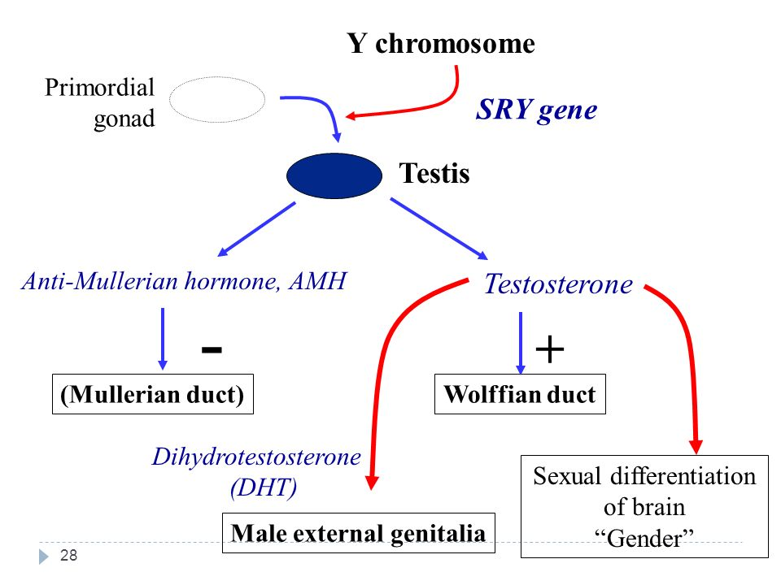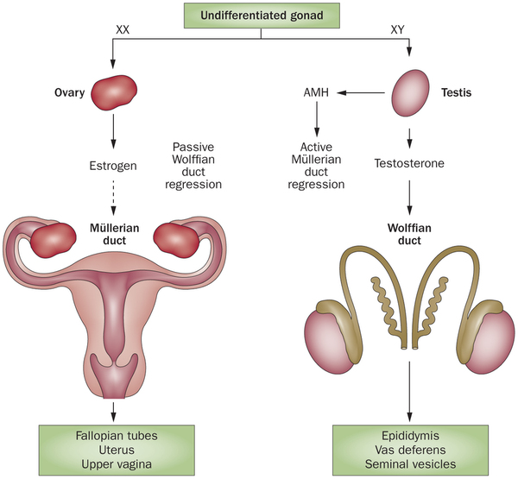

http://www.nature.com/nrendo/journal/v10/n8/images_article/nrendo.2014.83-f1.jpg

**Q: What are the key hormones in male fetal development:**

**A:**

* Testosterone 🡪 persistence and differentiation of Wolffian (mesonephric) ducts 🡪 differentiation into epididymis, ductus deferens, and ejaculatory ducts
* Anti-Mullerian hormone (produced by Sertoli cells)🡪 regression of Mullerian ducts

**Q: What conditions are required for normal female fetal development?**

**A:**

* Absence of TDF, testosterone, + Anti-Mullerian hormone 🡪 regression of Wolffian ducts and persistence of Mullerian (paramesonephric) ducts 🡪 differentiates into uterine (fallopian) tubes, uterus, uterine cervix, and upper vagina
* Therefore, the default is female unless the system is exposed to gene expression of the Y chromosome 🡪 SRY 🡪 androgenic steroids + anti-Mullerian hormone

**Q. What is Mullerian agenesis (Mayer-Rokitansky-Kuster-Hauser Syndrome aka MRKH)?**

**A:**

* XX karyotype  
  🡪 ovaries, normal estrogen production  
  🡪 normal external female genitalia
* Lower vagina normal
* Upper vagina, uterus, fallopian tubes absent (all are part of Mullerian tract)

**Q: Would an MRKH patient have normal breast development?**

**A:**

Yes, Normal ovarian function normal 🡪 normal breast development, normal secondary sexual characteristics, normal LH + FSH

**Q: What would the karyotype be for an MRKH patient?**

**A:**

Normal 46 XX karyotype

**Q: What other complications may be associated with MRKH?**

**A:**

40-50% of patients have renal complications because paramesonephric system develops with the renal system 🡪 kidneys develop from metanephros 🡪 all originates from urogenital ridge

**Q: What are some consequences of abnormal or incomplete fusion of Mullerian ducts?**

**A:**

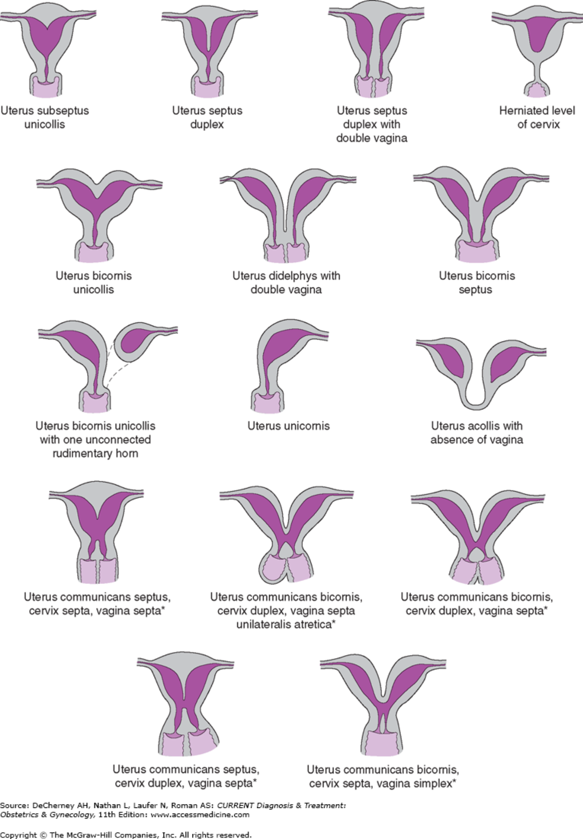

* Uterus Didelphys – when inferior parts of the Mullerian ducts do not fuse. (single or double vagina)
* Bicornuate Uterus – when superior portion of the uterine body do not fuse.
* Unicornuate Uterus +/- rudimentary horn – one duct poorly developed 🡪 remains as horn
* Septate uterus (complete or partial) – incomplete resorption of the fibrous septum between the two uterine horns
* Arcuate Uterus – Near complete resorption of the uterovaginal septum, small indentation at the fundus

**Application Questions:**

**Q: Would a 45, X individual (Turner Syndrome) have normal development of Mullerian structures?**

**A:**

Yes, Mullerian structures would develop similar to an XX female since there is absence of SRY gene = absence of testosterone + anti-Mullerian hormone. However, complete ovarian differentiation seems to require 2 X chromosomes 🡪 females with 45, X karyotypes have ovarian dysgenesis/streak ovaries

**Q: What characteristics would be present in an XY person with a mutation in anti-Mullerian hormone or anti-Mullerian hormone receptor?**

**A:**

Presence of male reproductive structures with persistence of Mullerian duct structures. This person may have an upper vagina, uterus, and uterine tubes as well as ductus deferens, undescended testes, and male external genitalia given the influence of testosterone. The inability to produce or respond to AMH causes lack of regression of Mullerian duct structures in an otherwise normal male individual.

**Practice Step 1 Question:**

A genetic male newborn has fully developed male sexual ducts and recognizable fallopian tubes. Which of the following processes was most likely disturbed during the embryonic period?

1. Production of estrogen by the embryonic testes
2. Production of Mullerian-inhibitory substance by the embryonic testes
3. Production of testosterone by the embryonic testes
4. Response of the paramesonephric (Mullerian) ducts to estrogen
5. Response of the paramesonephric (Mullerian) ducts to testosterone

Answer: B

*Explanation:*

Without the effects of Anti-Mullerian hormone (AMH) produced in Sertoli cells within the testes, the Mullerian ducts do not degenerate. In this particular case, the fetus still had the effects of SRY and testosterone, therefore normal development of male sexual ducts.

**References:**

Beckmann, Charles R. B. (Eds.) (2010) *Obstetrics and gynecology.*Baltimore, MD : Wolters Kluwer Health/Lippincott Williams & Wilkins

DeCherney AH, Nathan L, Laufer N, Roman AS. *CURRENT Diagnosis & Treatment: Obstetrics & Gynecology, 11e*; 2013 Available at: http://accessmedicine.mhmedical.com/content.aspx?

sectionid=41008590&bookid=498&Resultclick=2

Renu D, Rao B G, Ranganath K, Namitha. Persistent mullerian duct syndrome. Indian J Radiol Imaging 2010; 20:72-4